TASK11:
public class Solution {
public ListNode middleNode(ListNode head) {
ListNode slow = head;
ListNode fast = head;
while (fast != null && fast.next != null) {
fast = fast.next.next;
slow = slow.next;
}
return slow;
}
}

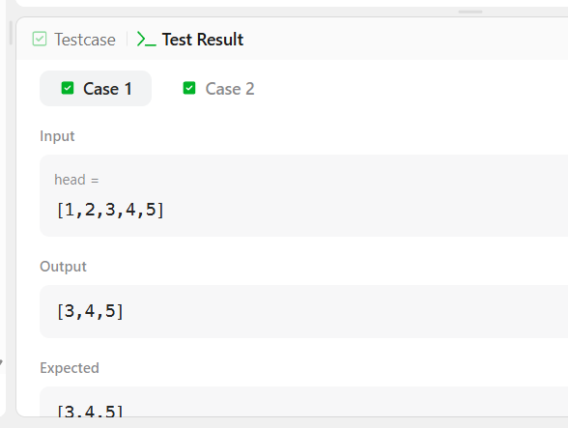

TASK12:
class Solution {
public boolean isPalindrome(ListNode head) {
if (head == null || head.next == null) {
return true;
}
// Find the middle of the linked list
ListNode slow = head;
ListNode fast = head;
while (fast != null && fast.next != null) {
slow = slow.next;
fast = fast.next.next;
}
// For odd number of nodes, skip the middle node
if (fast != null) {
slow = slow.next;
}
// Reverse the second half
ListNode prev = null;
while (slow != null) {
ListNode nextNode = slow.next;
slow.next = prev;
prev = slow;
slow = nextNode;
}
// Compare first half and reversed second half
ListNode first = head;
ListNode second = prev;
while (second != null) {
if (first.val != second.val) {
return false;
}
first = first.next;
second = second.next;
}
return true;
}
}

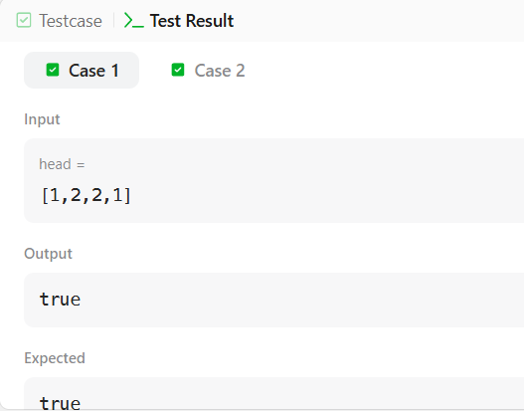

TASK13:
Class Solution {
public ListNode mergeTwoLists(ListNode list1, ListNode list2) {
// Create a dummy node
ListNode dummy = new ListNode(-1);
ListNode current = dummy;
// Compare nodes from both lists
while (list1 != null && list2 != null) {
if (list1.val <= list2.val) {
current.next = list1;
list1 = list1.next;
} else {
current.next = list2;
list2 = list2.next;
}
current = current.next;
}
// Attach remaining nodes
if (list1 != null) {
current.next = list1;
} else {
current.next = list2;
}
return dummy.next;
}
}

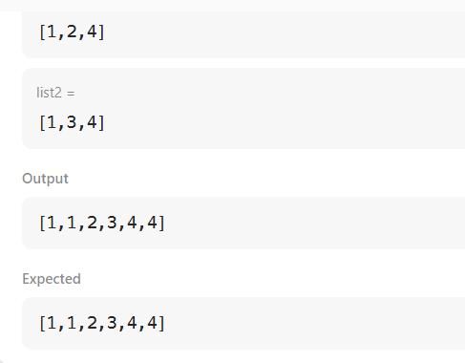

TASK 14:
class Solution {
public ListNode mergeKLists(ListNode[] lists) {
// Initialize a min-heap to store nodes based on their values
// The heap will always give us the node with the smallest value
PriorityQueue<ListNode> minHeap = new PriorityQueue<>((a, b) -> a.val - b.val);

// Add the head of each non-empty linked list to the heap
for (ListNode head : lists) {
if (head != null) {
minHeap.offer(head);
}
}

// Create a dummy node to simplify list construction
ListNode dummyHead = new ListNode();
ListNode current = dummyHead;

// Process nodes until the heap is empty
while (!minHeap.isEmpty()) {
// Extract the node with the smallest value
ListNode smallestNode = minHeap.poll();

// If this node has a next node, add it to the heap
// This ensures we continue processing the list this node came from
if (smallestNode.next != null) {
minHeap.offer(smallestNode.next);
}

// Append the smallest node to our result list
current.next = smallestNode;
current = current.next;
}

// Return the merged list, skipping the dummy head
return dummyHead.next;
}
}

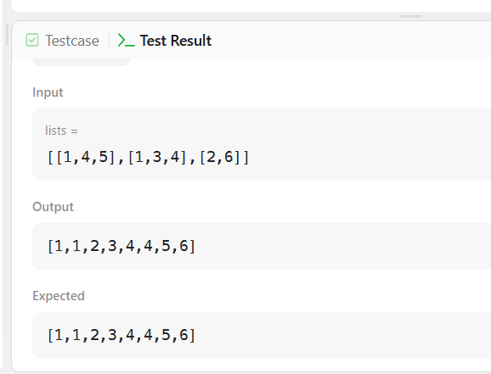

TASK 15:
class Solution {
public ListNode reverseList(ListNode head) {
ListNode prev = null;
ListNode cur = head;
while (cur != null) {
ListNode temp = cur.next;
cur.next = prev;
prev = cur;
cur = temp;
}
return prev;
}
}

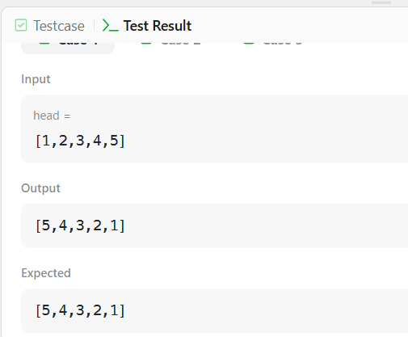

TASK 16:
class Solution {
public ListNode reverseKGroup(ListNode head, int k) {
// Dummy node before the head
ListNode dummy = new ListNode(0);
dummy.next = head;
ListNode groupPrev = dummy;
while (true) {

// Find the kth node
ListNode kth = getKthNode(groupPrev, k);

// If fewer than k nodes remain, don't reverse them
if (kth == null) {
break;
}

ListNode groupNext = kth.next;

// Reverse the group
ListNode prev = groupNext;
ListNode curr = groupPrev.next;

while (curr != groupNext) {
ListNode temp = curr.next;
curr.next = prev;
prev = curr;
curr = temp;
}
// Connect previous part to reversed group
ListNode temp = groupPrev.next;
groupPrev.next = kth;
// Move groupPrev to the end of reversed group
groupPrev = temp;
}
return dummy.next;
}
// Find the kth node from groupPrev
private ListNode getKthNode(ListNode curr, int k) {
while (curr != null && k > 0) {
curr = curr.next;
k--;
}
return curr;
}
}

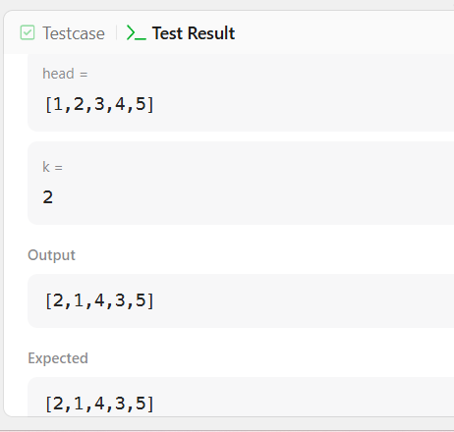

TASK17:
class Solution {
public ListNode detectCycle(ListNode head) {
ListNode slow = head;
ListNode fast = head;
while (fast != null && fast.next != null) {
slow = slow.next;
fast = fast.next.next;
if (slow == fast) {
ListNode start = head;
while (start != slow) {
start = start.next;
slow = slow.next;
}
return start;
}
}
return null;
}
}
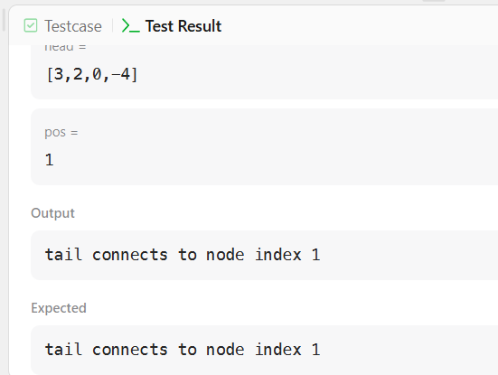
TASK 18:
public class Solution {
public ListNode getIntersectionNode(ListNode headA, ListNode headB) {
ListNode p1 = headA;
ListNode p2 = headB;
while (p1 != p2) {
if (p1 == null) {
p1 = headB;
} else {
p1 = p1.next;
}
if (p2 == null) {
p2 = headA;
} else {
p2 = p2.next;
}
}
return p1;
}
}
